Multiple Store controller instance causes inconsistent of store data.

1.1 Design Problem
In existing design, the Store Controller is used for retrieval and update of Drink store and Coin store. Currently, Store Controller is only created in Main Controller and always accessible from Main Controller. If some other class create Store Controller by it self, then more than one store controllers exists in the system, which will cause inconsistent of Drink store and coin store item information.

1.2 Pattern Selection

1.2.1 Candidate Design Patterns
- Singleton
  - Ensure a class only has one instance and provide a global point of access to it.
- Facade
  - Provide a unified interface to a set of interfaces in a subsystem.
  - Façade defines a higher-level interface that makes the subsystem easier to use.

1.2.2 Motivations to Choose
Singleton pattern is selected to solve this problem.
Reasons for choosing:
- Drink Store Item and Coin Store Item are shared global resources and should be controlled by only one instance class of Store Controller. Having single instance provides consistency of data in the system.

1.3 Design Changes

1.3.1 Initial Design
Store Controller Class Diagram
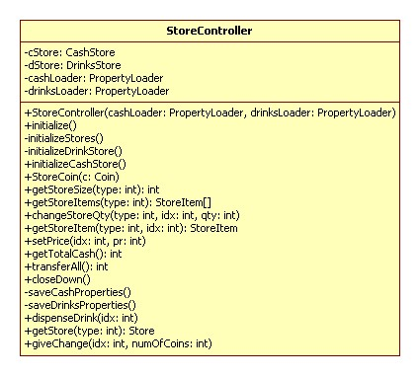
Main Controller initiation Sequence Diagram
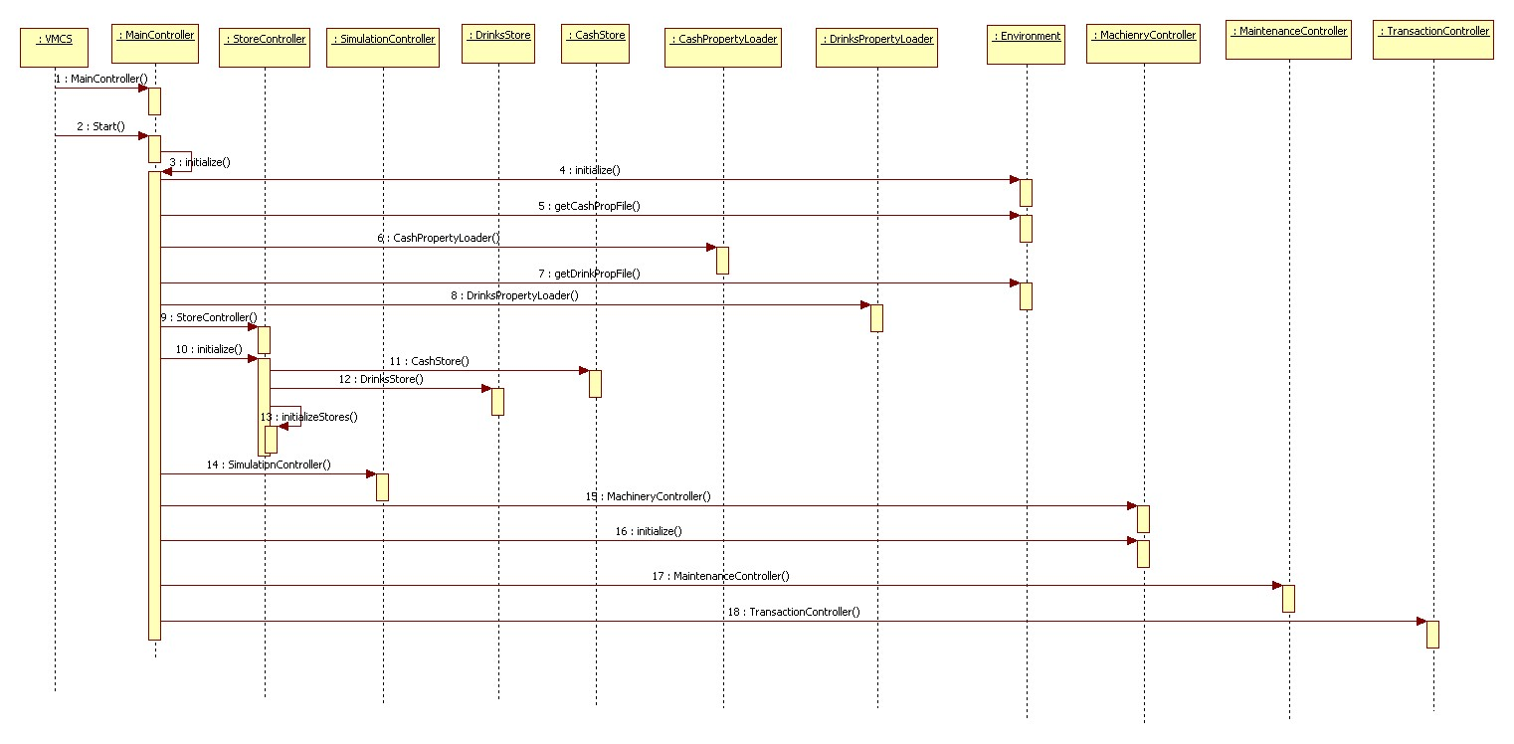

1.3.2 Modified Design
Store Controller Class Diagram
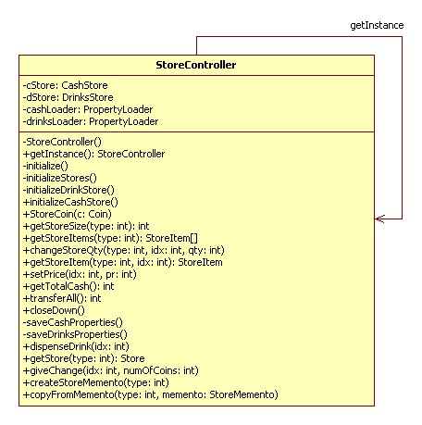
Main Controller initiation Sequence Diagram
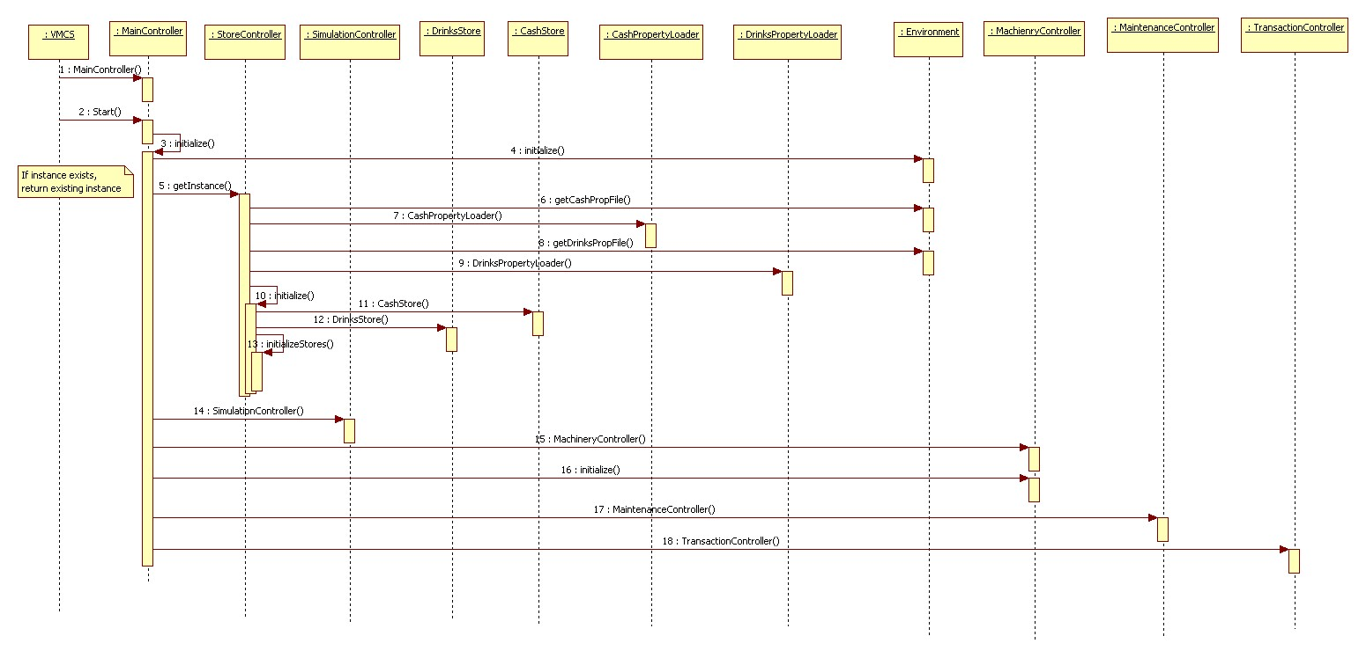

1.4 Implementation

- Ensuring a unique instance
  - Changed public constructor to private constructor in Store Controller class and introduced getInstance public static method to return the global instance.
  - Static field is used for holding store controller instance. If instance is not created earlier then only new instance is creating otherwise existing created returning to the caller.

